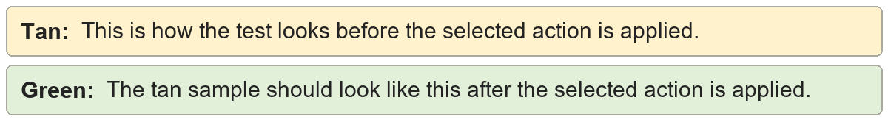
Direct character formatting | Shared formatting sample.
Direct character formatting | Shared formatting sample.

Direct paragraph formatting | Shared formatting sample.
Direct paragraph formatting | Shared formatting sample.

Preserve highlighting | The emphasized words remain highlighted.
Preserve highlighting | The emphasized words remain highlighted.

Quick emphasis | A whole paragraph keeps its emphasis.
Quick emphasis | A whole paragraph keeps its emphasis.

Thorough emphasis | One important word keeps emphasis.
Thorough emphasis | One important word keeps emphasis.

Strip emphasis | Direct emphasis is removed from this sentence.
Strip emphasis | Direct emphasis is removed from this sentence.

